**Apache Spark Lab: K-means clustering**

Succesfully downloaded 10 percent data

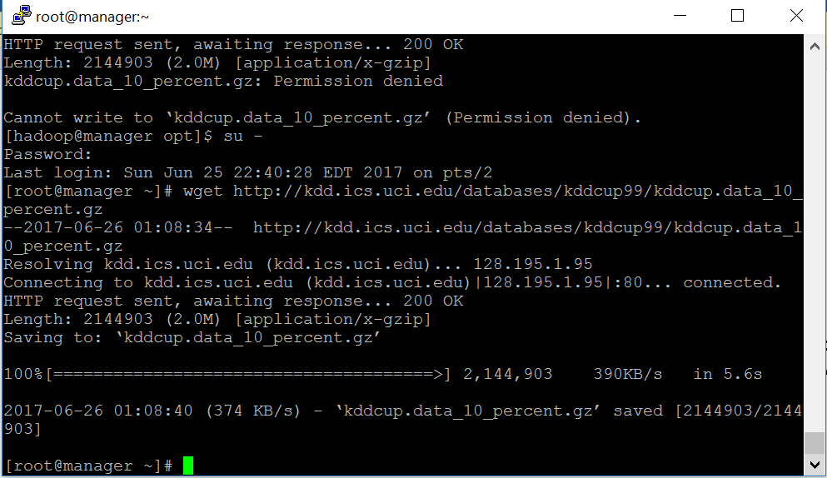

Copied 10 percent file into HDFS

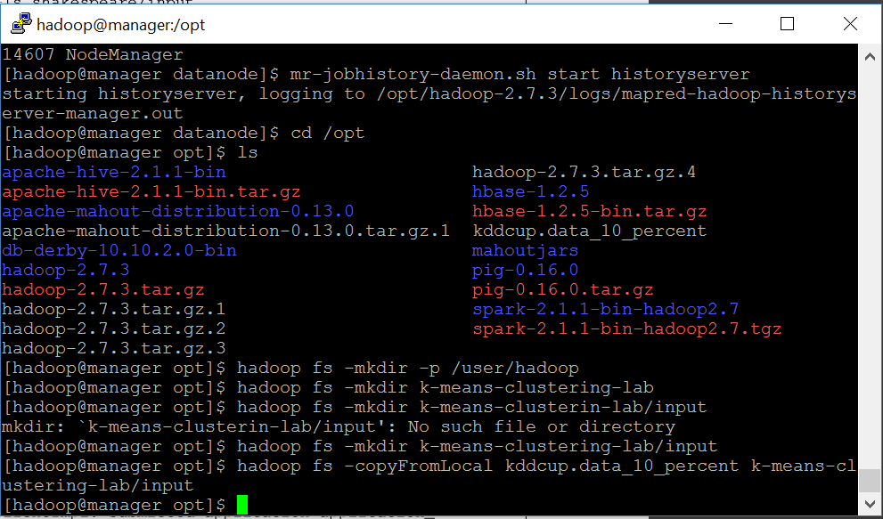

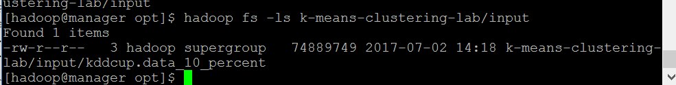

Spark commands loading textfile as source

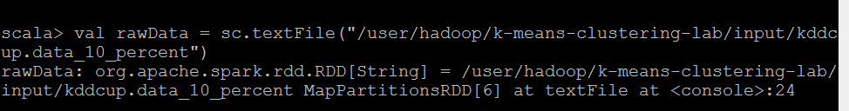

Data mapping manipulation on text file

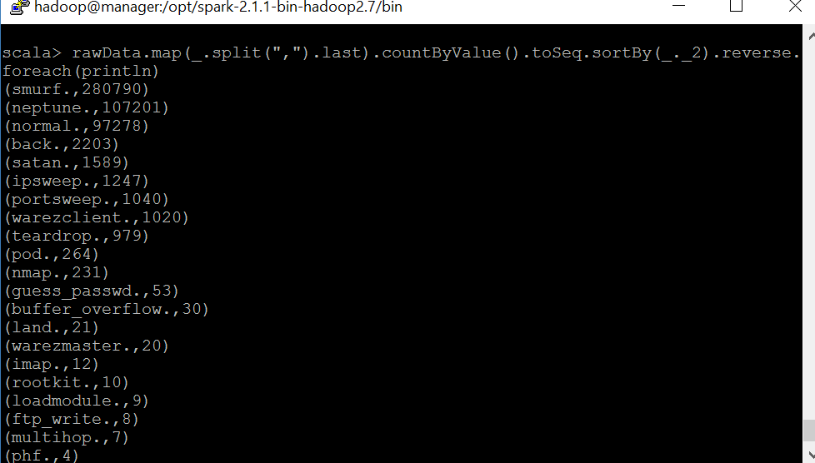

Imported library of functions

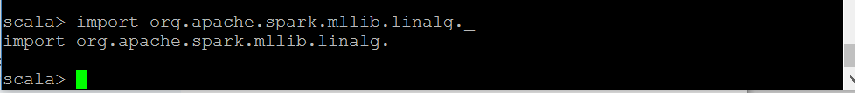

Scala functions for finding centroids and cluster anomalies

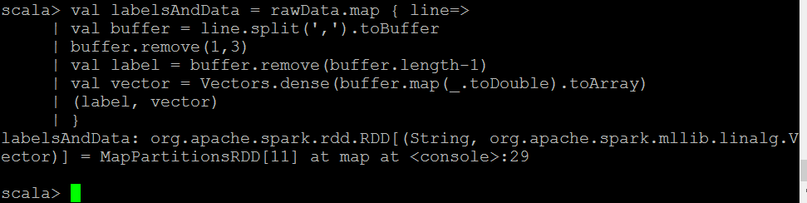







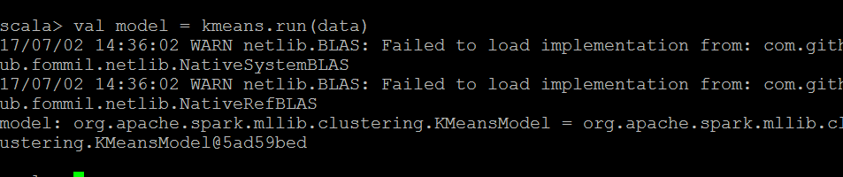

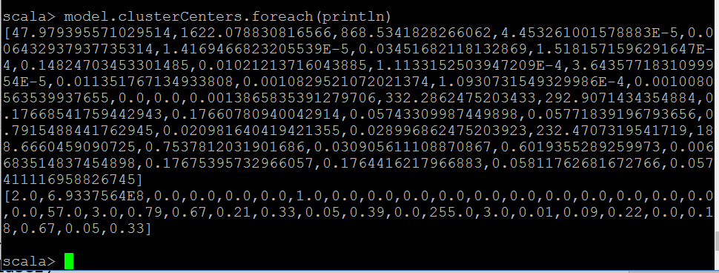

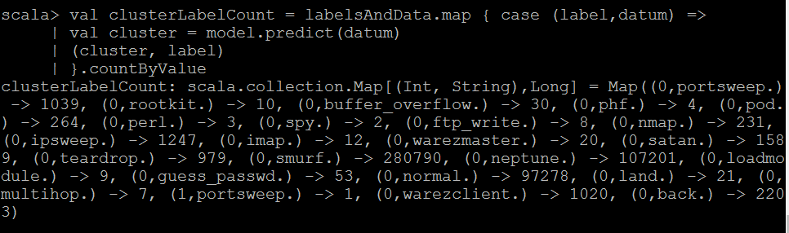

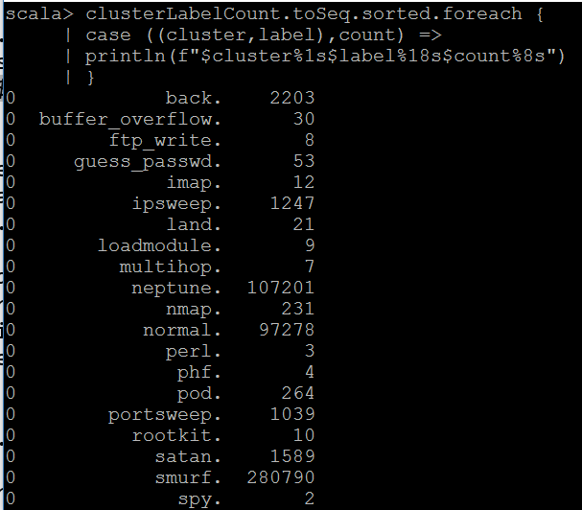

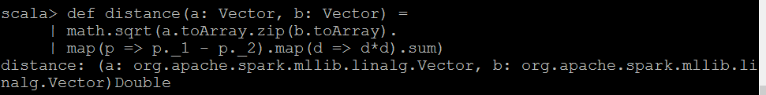

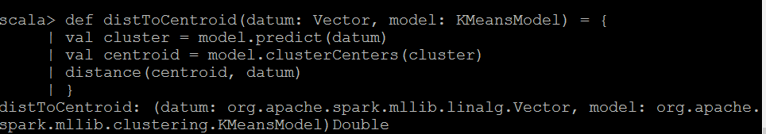

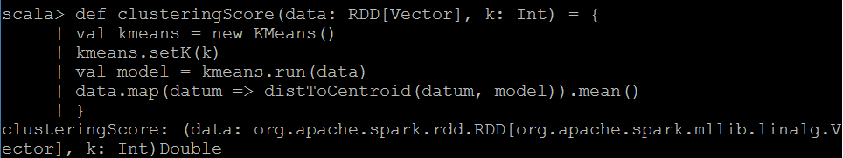

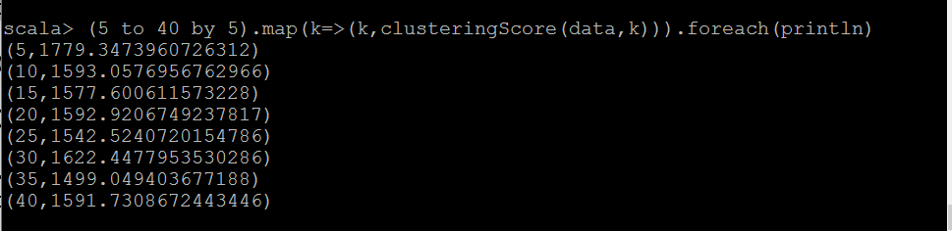

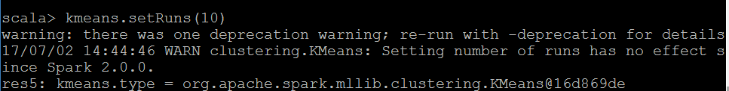



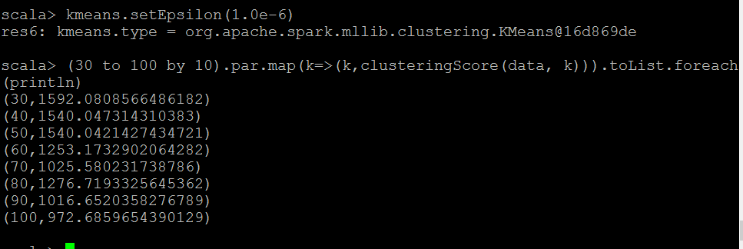

Thanks Professor Busch for all the hands on help this semester!

I learned a lot